

Software Engineering for Industrial Applications
Mandatory Internship SoSe-2026

Development of
AI-powered Retrieval-Augmented
Generation (RAG) system
“Software Validation Report”

Submitted To  Prof. Dr. Matthias Meitner  Hof University of Applied Science | Submitted By  Md Fahim Hossain  Student ID: 00154924

Table of Contents
1. Introduction & Company Overview 3
1.1. Introduction 3
1.2. Company Overview 3
1.3. Department Overview 4
1.4. Motivation for the Project 4
2. Role & Tasks 5
3. Project Overview 5
4. Tools & Frameworks 6
5. Code Review Process 8
5.1. Self-Review and Refactoring 8
5.2. Architectural Review and Code Quality Improvements 9
5.3. Final Review Before Feature Completion 10
6. Testing 11
6.1. Unit Testing 11
6.1.1. Testing the Document Chunking Service 12
6.1.2. Testing the PDF Extraction Service 12
6.1.3. Testing the Word Extraction Service 13
6.1.4. Testing the Excel Extraction Service 14
6.1.5. Testing the RAG Retrieval Service 15
6.2. API Testing 16
6.2.1. Testing the Embedding API Integration 17
6.2.2. Testing the Language Model API Integration 18
6.2.3. Testing API Failure Scenarios 19
6.3. Load Testing 20
6.3.1. Concurrent Document Processing 20
6.3.2. Concurrent Question Answering 21
6.3.3. Database Performance During Retrieval 21
6.3.4. Overall System Stability 22
6.4. Test Cases 22

List of Tables
Table 1: TC01 – Document Upload Test Data 23
Table 2: TC02 – Document Processing Pipeline Test Data 24
Table 3: TC03 – AI-Assisted Question Answering Test Data 25
Table 4: TC04 – Multi-Document Retrieval Test Data 26
Table 5: TC05 – Conversation History Test Data 27
Table 6: TC06 – Document Deletion Test Data 27
List of Figures
Figure 1: Dispatching background document processing after a successful upload 9
Figure 2: Document processing with asynchronous embedding generation 10
Figure 3: Unit test verifying document chunk generation and metadata preservation 12
Figure 4: Unit test validating PDF text normalization 13
Figure 5: Unit test verifying Word document text extraction 14
Figure 6: Unit test verifying spreadsheet text extraction 15
Figure 7: Unit test verifying semantic document retrieval 16
Figure 8: Mocking the embedding API response 17
Figure 9: Verifying the embedding API request and response 18
Figure 10: Mocking the language model API response 18
Figure 11: Verifying prompt construction before the language model request 19
Figure 12: Verifying missing API credentials and unsupported provider configurations 19
Figure 13: Laravel queue worker processing documents during concurrent uploads 20

Introduction & Company Overview

Introduction
As part of the Master's program in Software Engineering for Industrial Applications at Hof University of Applied Sciences, students are required to apply theoretical knowledge in a practical industrial environment through project-based work. This report documents the software verification and validation activities performed during the development of an AI-powered Retrieval-Augmented Generation (RAG) system for enterprise document management and knowledge retrieval.
Modern organizations generate and maintain large volumes of technical documents, reports, manuals, process descriptions, and operational guidelines. Accessing relevant information from these documents often requires significant manual effort, leading to reduced efficiency and increased time spent searching for knowledge. To address this challenge, an intelligent document retrieval system was designed and developed that combines document processing, semantic search, and Artificial Intelligence technologies to provide context-aware answers based on organizational documents.
The project was developed during my work as a Working Student at Siemens Energy. The development process involved requirements analysis, software specification, system design, architecture planning, implementation, and validation of the proposed solution. This report focuses on the verification and validation activities performed during development. It describes the code review process, unit testing, API testing, performance testing, functional test cases, and validation activities carried out to ensure that the developed system satisfies its specified requirements and operates reliably under practical conditions.
The objective of the project was to develop a scalable and maintainable software solution that can process organizational documents, retrieve relevant information, and help users find answers through natural language queries.

Company Overview
Siemens Energy is one of the world's leading energy technology companies, operating across the entire energy value chain. The company develops innovative solutions for power generation, transmission, storage, and industrial applications while supporting the global transition toward sustainable and reliable energy systems.
With operations in more than 90 countries and a workforce of approximately 100,000 employees worldwide, Siemens Energy serves customers in both conventional and renewable energy sectors. The company provides technologies and services for gas turbines, steam turbines, power generation systems, grid infrastructure, hydrogen solutions, industrial applications, and digital transformation initiatives.
Digitalization plays a critical role in Siemens Energy's strategy. The company continuously invests in advanced software solutions, data-driven decision making, artificial intelligence, cloud technologies, and process automation to improve operational efficiency and support business innovation. These initiatives enable employees and stakeholders to access information more effectively, optimize workflows, and enhance organizational productivity.

Department Overview
The project was conducted within the SE GT DG OE department of Siemens Energy.
The department is involved in supporting digitalization initiatives, process optimization, and data-driven solutions that enhance operational efficiency across business functions. Various software tools, reporting systems, and analytical platforms are utilized to manage information, automate processes, and improve collaboration among stakeholders.
As part of ongoing digital transformation efforts, the department actively explores modern technologies such as cloud platforms, data analytics, artificial intelligence, and enterprise software systems. These technologies are used to streamline business processes, improve knowledge management, and support informed decision-making.
The development of the AI-powered document retrieval system aligns with these objectives by providing an intelligent mechanism for managing and accessing organizational knowledge. The project contributes to the broader goal of improving information accessibility and reducing the effort required to locate relevant content within large collections of enterprise documents.

Motivation for the Project
Organizations frequently store critical knowledge across numerous documents, including technical manuals, operational procedures, project documentation, and internal reports. Although these documents contain valuable information, retrieving specific content often requires manual searching, which can be time-consuming and inefficient.
The increasing adoption of Artificial Intelligence technologies has created opportunities to enhance document management systems through semantic understanding and context-aware information retrieval. Instead of relying solely on keyword-based searches, modern AI-assisted systems can understand user intent and identify relevant information based on contextual meaning.
The motivation behind this project was to design and develop a software solution capable of improving access to organizational knowledge while maintaining a user-friendly experience. By integrating document processing, semantic retrieval mechanisms, and AI-assisted response generation, the proposed system aims to support employees in obtaining accurate information quickly and efficiently.
The project also provided an opportunity to apply software engineering principles, including requirements engineering, system design, architectural modeling, and software development methodologies within a real industrial environment.
- Role & Tasks
During my internship at Siemens Energy, I worked as a Working Student in the Digital Solutions team, contributing to both enterprise software development and data engineering activities. My responsibilities included supporting internal data analytics initiatives while leading the design and development of an AI-powered Retrieval-Augmented Generation (RAG) system for enterprise document management and knowledge retrieval. Throughout the internship, I collaborated with software engineers and business stakeholders to analyse requirements, design software components, implement new features, and document the developed solution.
My primary responsibility was the development of the RAG system. I participated in the complete software development lifecycle, including requirements analysis, system design, backend development, user interface implementation, and technical documentation. The system was designed to provide secure and efficient access to enterprise knowledge through semantic search and AI-assisted question answering.
As part of this work, I developed the document management and processing workflow, enabling users to upload documents, monitor processing progress, and retrieve information through a conversational interface. I also implemented semantic retrieval, conversation management, and background processing features to support efficient document indexing and question answering. In addition, I contributed to improving the system architecture, optimizing database operations, and preparing the application for containerized deployment.
Alongside the RAG project, I supported enterprise data engineering activities involving Python, SQL, and Snowflake. My work included developing and validating data processing workflows, transforming business data for reporting purposes, and contributing to the development of Power BI dashboards in collaboration with domain experts.
Throughout the internship, I actively participated in team discussions, code reviews, and technical knowledge-sharing sessions. These activities improved both the software and my understanding of collaborative development practices. I also prepared technical documentation to support future maintenance and continued development of the application.
The combination of enterprise software development, AI-assisted document retrieval, and data engineering provided valuable experience in designing scalable software systems, collaborating within multidisciplinary teams, and applying software engineering principles to solve practical industrial challenges.

Project Overview
The project developed during this internship is an AI-powered Retrieval-Augmented Generation (RAG) system designed to improve enterprise document management and knowledge retrieval. The application enables users to upload organizational documents, process them automatically, and interact with their contents through a conversational interface. Instead of manually searching through lengthy reports or technical documentation, users can ask questions in natural language and receive responses generated from the relevant information contained within the uploaded documents.
The primary objective of the system is to improve information accessibility while ensuring that responses are generated from trusted organizational documents rather than relying solely on the knowledge of a language model. By combining semantic document retrieval with AI-assisted response generation, the system provides context-aware, document-grounded answers while supplying only the most relevant document content for response generation.
Document Upload and Processing
Users can upload and manage enterprise documents through a centralized repository. After upload, the system automatically extracts document text, performs preprocessing, divides the content into semantic chunks, and prepares it for retrieval. This automated processing pipeline minimizes manual effort and ensures that documents become searchable once processing has been completed.
Semantic Retrieval and Question Answering
The system retrieves relevant document sections using semantic similarity rather than exact keyword matching, allowing users to ask questions in natural language. The retrieved document content is then provided to a language model, which generates context-aware responses grounded in the uploaded documents. The application also presents document references so that users can verify the origin of the retrieved information.
Conversation Management
The application provides a conversation-oriented interface where users can create multiple conversations, select one or more processed documents as knowledge sources, review previous discussions, and continue asking follow-up questions while preserving conversational context.
System Architecture
The system follows a modular architecture that separates document management, document processing, semantic retrieval, conversational interaction, and background processing into independent components. This design improves maintainability, scalability, and extensibility, allowing future enhancements to be incorporated with minimal impact on the existing system.
Overall, the developed RAG system combines automated document processing, semantic search, and AI-assisted question answering within a unified platform for enterprise knowledge retrieval. The solution improves information accessibility, reduces the effort required to locate relevant knowledge, and provides employees with an efficient and reliable way to interact with organizational documents.

Tools & Frameworks
The development and verification of the AI-powered document retrieval system relied on a combination of backend technologies, development tools, testing utilities, and supporting frameworks. These tools were selected to ensure that the application could be implemented efficiently while also providing mechanisms for debugging, validating functionality, and maintaining software quality throughout the development lifecycle.
Laravel Framework
Laravel 12 served as the primary backend framework for implementing the application. It provided the overall project structure, routing, authentication, middleware, database abstraction, queue management, and testing support. Its modular architecture enabled individual components to be developed and verified independently while maintaining clean separation between business logic and presentation.
PostgreSQL and pgvector
PostgreSQL was used as the primary relational database for storing application data, including users, uploaded documents, conversations, and metadata. The pgvector extension enabled efficient storage and similarity search of document embeddings, allowing semantic document retrieval to be validated during functional testing. The database also supported verification of data integrity and consistency throughout the testing process.
AI Models
The system utilizes two different AI models during document processing and question answering. An embedding model generates vector representations of document chunks, while a language model produces context-aware responses using the retrieved information. During validation, these models were tested with different document collections to verify retrieval accuracy, citation generation, and response relevance.
Poppler and Tesseract OCR
Poppler was used to extract text from digitally generated PDF documents, while Tesseract OCR processed scanned documents containing image-based text. Both tools were validated using documents with different layouts and formats to ensure that extracted text was sufficiently accurate for subsequent indexing and semantic retrieval.
Queue Processing
Laravel's queue system was used to execute computationally intensive tasks such as document parsing, embedding generation, and indexing asynchronously. Background job processing allowed the application to remain responsive during large document uploads while simplifying verification of processing workflows and error handling.
Git and GitHub
Git was used throughout development to manage source code changes and maintain version history. GitHub served as the central repository for collaboration, feature integration, and code review. The version control workflow simplified tracking code modifications, reviewing changes before merging, and reverting implementations when necessary.
Docker
Docker was used to containerize the application and its supporting services, providing a consistent development and deployment environment. Containerization reduced environment-specific configuration issues and simplified validation by ensuring that the application behaved consistently across different development machines.
Development and API Testing Tools
Several development tools were used throughout implementation and verification:
- Visual Studio Code served as the primary integrated development environment for implementing and debugging the application.
- Postman was used to verify backend API endpoints, authentication mechanisms, request validation, and response handling.
- PgAdmin was used to inspect database records, verify data integrity, execute SQL queries, and validate vector storage and retrieval.
- Browser Developer Tools were used to debug frontend interactions, inspect network requests, monitor JavaScript execution, and validate user interface behavior.
Performance and Load Testing
Performance testing focused on evaluating the responsiveness of the application under concurrent user activity. Multiple document uploads, simultaneous chat requests, and background processing tasks were executed to observe application stability, queue execution, and database performance. These tests helped identify potential bottlenecks and verify that the system maintained acceptable response times during typical workloads.

Code Review Process
Software quality was continuously improved throughout the development of the AI-powered document retrieval system by performing regular code reviews during implementation. Rather than treating code review as a single activity before deployment, reviews were conducted whenever a new feature, enhancement, or bug fix was completed. This iterative review process helped maintain code readability, reduce defects, and ensure that newly developed components integrated correctly with the existing architecture.
Since the project followed an incremental development approach, every major functionality—including document upload, document processing, semantic retrieval, conversation management, OCR support, and administrative features—was reviewed before being considered complete. The review process primarily focused on maintainability, correctness, performance, and consistency with Laravel development practices.
The review activities were organized into three stages.

Self-Review and Refactoring
The first stage of the review process was performed immediately after implementing a new feature. Before considering the implementation complete, the code was manually reviewed to identify potential improvements and eliminate unnecessary complexity.
During this stage, the following aspects were verified:
- Compliance with Laravel coding conventions.
- Removal of duplicated logic.
- Clear naming of variables, methods, and classes.
- Proper separation of responsibilities between controllers, services, and background jobs.
- Exception handling for possible runtime failures.
- Database operations executed only when required.
- Readability and maintainability of the implementation.
A common design decision throughout the project was keeping controllers lightweight by limiting their responsibilities to request validation, authorization, and dispatching background processing tasks. Computationally expensive operations such as document parsing, text chunking, and embedding generation were intentionally moved into dedicated queue jobs. This approach simplified both development and later verification because each component had a clearly defined responsibility.
For example, after a document upload is validated and stored, the controller simply dispatches a background processing job instead of performing the complete document processing workflow synchronously.
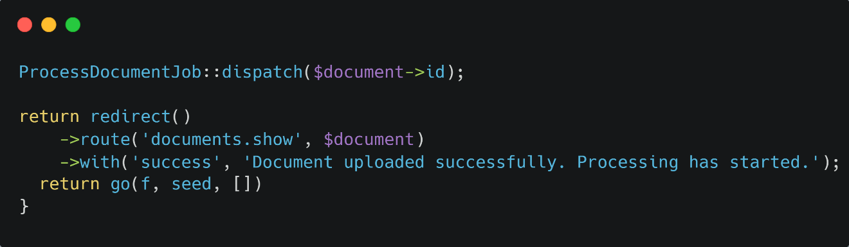
Figure 1: Dispatching background document processing after a successful upload
This implementation improves readability, reduces controller complexity, and prevents long-running operations from blocking the user interface.

Architectural Review and Code Quality Improvements
After the initial implementation, the project structure was reviewed from an architectural perspective to ensure that new functionality remained consistent with the overall system design.
The review concentrated on several important software engineering principles:
- Single Responsibility Principle for controllers, services, and jobs.
- Reusability of shared services.
- Consistent error handling.
- Proper database transaction management.
- Efficient interaction with external services.
- Clear separation between business logic and presentation logic.
During this stage, several improvements were introduced as the project evolved. For example:
- Business logic was gradually moved from controllers into dedicated service classes.
- Background processing was separated into queue jobs.
- Common functionality was reused instead of duplicated.
- Exception handling and logging were standardized.
- Database updates involving multiple operations were grouped into transactions.
The document processing workflow illustrates this design. After text extraction is completed successfully, the database updates are executed within a transaction before the next embedding generation job is dispatched.
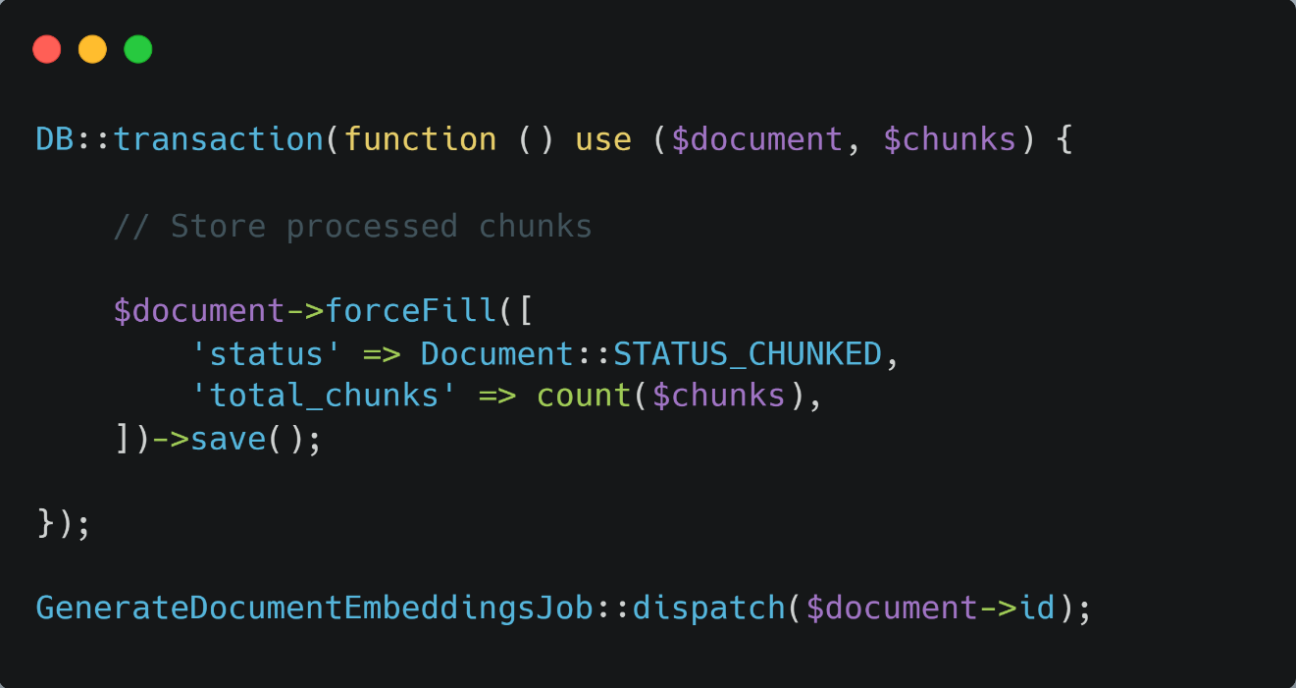
Figure 2: Document processing with asynchronous embedding generation
Using database transactions ensured that incomplete processing could not leave the system in an inconsistent state. Dispatching the embedding generation as a separate background job also improved scalability and simplified independent testing of each processing stage.

Final Review Before Feature Completion
Before a feature was considered complete, a final review was performed to verify both implementation quality and functional correctness. This review ensured that the feature integrated correctly with the remainder of the system and behaved as expected under realistic usage scenarios.
The final review included verification of:
- Correct execution of application workflows.
- Database consistency after user actions.
- Proper queue execution and background processing.
- Accurate handling of exceptional conditions.
- User interface behaviour and validation messages.
- Compliance with project coding standards.
- Compatibility with previously implemented features.
Particular attention was given to features involving multiple components, such as document upload, OCR processing, semantic indexing, and AI-assisted question answering. Since these features interact with several independent modules, successful completion required verification of the entire processing pipeline rather than individual functions alone.
Any issues identified during this stage were corrected before proceeding to the formal verification activities described in the next chapter. Once the code review process had been completed, automated unit tests, API integration tests, load testing, and functional test cases were executed to validate the correctness of the implemented features. Performing code reviews before testing reduced the number of defects entering the verification phase and improved the overall reliability and maintainability of the software.

Testing
Testing was carried out throughout the development of the AI-powered document retrieval system to verify the correctness, reliability, and robustness of the implemented software components. The testing process aimed to ensure that individual modules behaved as expected, external integrations functioned correctly, and the complete application satisfied its functional requirements before deployment.
To achieve this, multiple testing approaches were adopted throughout development. Automated unit tests were implemented using Laravel's PHPUnit testing framework to verify the behaviour of individual services in isolation. API testing validated communication with external AI services, while load testing and functional test cases evaluated the application's behaviour under realistic operating conditions.
Because the application consists of several independent components, including document extraction, document chunking, semantic retrieval, vector embedding generation, and AI-assisted response generation, testing was performed incrementally as each feature was completed. This modular approach simplified debugging, reduced regression issues, and improved the overall maintainability of the software.
The following sections describe the testing activities performed during the project.

Unit Testing
Unit testing focused on verifying the behaviour of individual software components independently before they were integrated into the complete document processing workflow. Laravel's built-in PHPUnit testing framework was used to implement automated unit tests located under the tests/Unit directory, allowing each service to be validated under controlled conditions without depending on other modules of the application.
Unlike integration testing, each unit test concentrated on a single responsibility of the corresponding service. This approach simplified debugging, enabled regression testing after code modifications, and ensured that individual components continued to function correctly throughout the development process.
The automated unit tests implemented during the project covered the core document processing services, including document chunking, text extraction from multiple document formats, OCR decision logic, and semantic retrieval. Together, these components form the foundation of the document processing pipeline and therefore required comprehensive verification before integration with the remaining system.

Testing the Document Chunking Service
The DocumentChunker service is responsible for dividing extracted document content into manageable semantic chunks while preserving the metadata required for later retrieval and citation generation. Since this service directly influences the quality of semantic search, automated tests were implemented to verify correct chunk generation for different document sources and extraction methods.
The following test verifies that page information and extraction metadata are correctly preserved during the chunking process.
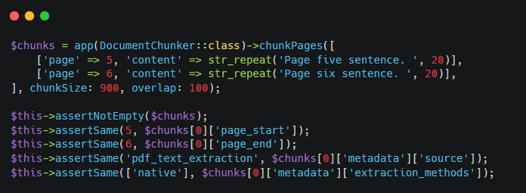
Figure 3: Unit test verifying document chunk generation and metadata preservation
Test Objectives
- Verify correct chunk generation.
- Confirm preservation of page boundaries.
- Validate extraction metadata.
- Verify document source identification.
- Ensure generated chunks remain suitable for semantic retrieval.
Expected Outcome
The generated chunks preserve document structure, page information, and extraction metadata, ensuring accurate semantic retrieval and citation generation.
The remaining unit tests for this service additionally verify OCR metadata preservation, spreadsheet metadata handling, and UTF-8 character integrity to ensure reliable processing of different document types.

Testing the PDF Extraction Service
The PdfExtractorService is responsible for extracting and normalizing textual content from PDF documents before further processing. Since extracted text may contain unwanted control characters, encoding artifacts, or formatting inconsistencies, automated tests were implemented to verify that the normalization process preserves meaningful content while removing extraction noise.
The following test validates the text normalization behaviour.
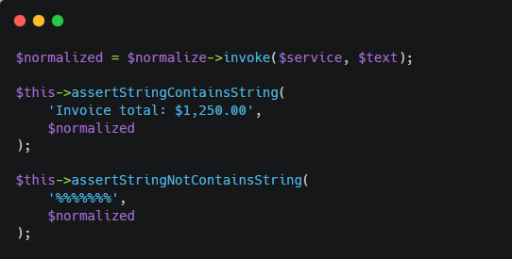
Figure 4: Unit test validating PDF text normalization
Test Objectives
- Verify removal of extraction artifacts.
- Preserve meaningful document content.
- Validate UTF-8 encoding.
- Remove invalid control characters.
- Improve extracted text quality.
Expected Outcome
The normalization process removes unwanted characters while preserving readable document content for subsequent indexing and semantic retrieval.

Testing the Word Extraction Service
The WordExtractorService extracts textual information from Microsoft Word documents while preserving the logical reading order of the original document. Automated tests were implemented to verify that document text was extracted correctly from supported Word formats and remained suitable for subsequent processing.
The unit tests validate successful extraction of textual content and confirm that the returned output is correctly formatted before entering the document chunking stage.
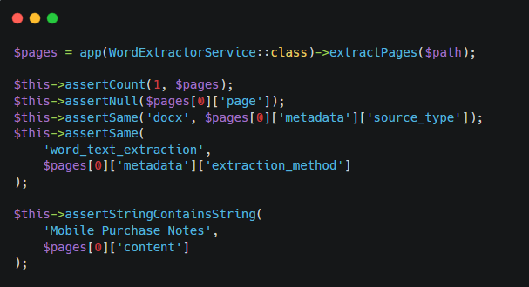
Figure 5: Unit test verifying Word document text extraction
Test Objectives
- Verify successful text extraction.
- Preserve document content.
- Validate extracted text format.
- Confirm compatibility with the document processing pipeline.
Expected Outcome
Text is extracted successfully from Word documents and prepared for semantic chunk generation without losing relevant information.

Testing the Excel Extraction Service
The ExcelExtractorService extracts structured data from spreadsheet documents while preserving worksheet information and row-level context. Automated tests were implemented to verify that spreadsheet data is converted into meaningful textual representations suitable for semantic indexing.
The unit tests confirm that worksheet names, row information, and extracted values are correctly preserved during processing.
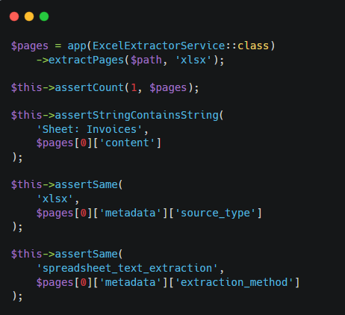
Figure 6: Unit test verifying spreadsheet text extraction
Test Objectives
- Verify spreadsheet text extraction.
- Preserve worksheet metadata.
- Validate row information.
- Confirm compatibility with semantic indexing.
Expected Outcome
Spreadsheet contents are transformed into structured textual representations while preserving contextual metadata required during retrieval.

Testing the RAG Retrieval Service
The RagRetrievalService is responsible for retrieving the most relevant document chunks based on semantic similarity before they are provided to the language model for response generation. As this component represents the core retrieval mechanism of the RAG system, automated tests were implemented to verify retrieval accuracy, document filtering, and result ranking.
The unit tests verify that only the appropriate document chunks are retrieved and that the returned results satisfy the specified similarity criteria.
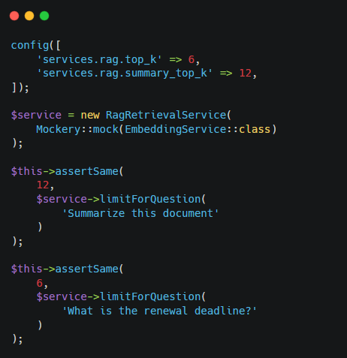
Figure 7: Unit test verifying semantic document retrieval
Test Objectives
- Verify semantic retrieval accuracy.
- Confirm document filtering.
- Validate similarity ranking.
- Ensure correct retrieval of relevant document chunks.
Expected Outcome
The retrieval service consistently returns the most relevant document chunks for subsequent response generation while respecting the specified retrieval criteria.

API Testing
The AI-powered document retrieval system relies on two external AI services to perform semantic document retrieval and response generation. The first service generates vector embeddings for document chunks, while the second generates context-aware answers based on the retrieved document content. Since both services communicate through external HTTP APIs, dedicated API testing was performed to verify successful communication, request construction, response processing, and exception handling.
Unlike the internal application components tested during unit testing, API testing focused on validating the interaction between the application and external AI services. Automated tests were implemented using Laravel's testing framework together with HTTP request mocking. This approach allowed the API integration to be verified without requiring actual network communication, resulting in faster, repeatable, and deterministic test execution.
The API tests verified successful responses, invalid configurations, request formatting, and error handling to ensure reliable integration with both external services.

Testing the Embedding API Integration
The embedding service is responsible for converting extracted document text into numerical vector representations that are later stored within the vector database for semantic similarity search. Automated tests were implemented to verify that the embedding service constructs the correct API request, sends the required parameters, and correctly processes the returned embedding vector.
The test simulates the external API response using Laravel's HTTP mocking functionality.
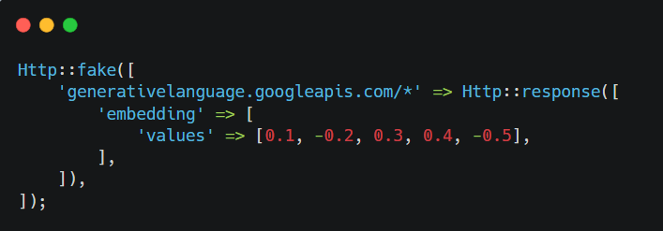
Figure 8: Mocking the embedding API response
Test Objectives
- Verify correct API request generation.
- Validate successful embedding generation.
- Confirm correct parsing of the returned vector.
- Verify embedding dimensions.
- Ensure no real network communication is required during testing.
Expected Outcome
The embedding service successfully processes the simulated API response and returns the expected embedding vector for further processing.
After generating the embedding, the automated test verifies both the returned values and the correctness of the outgoing HTTP request.
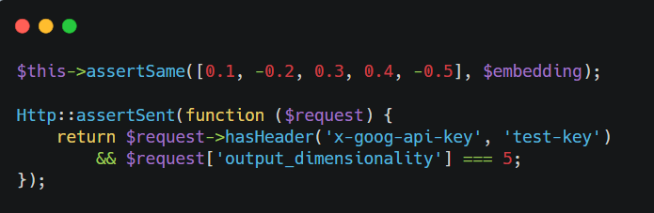
Figure 9: Verifying the embedding API request and response

Testing the Language Model API Integration
After relevant document chunks have been retrieved, the language model generates the final response presented to the user. API testing verified that the application correctly constructs the prompt, communicates with the external language model, and processes the generated response.
The external service was simulated using HTTP mocking. This approach allows the tests to execute deterministically without depending on external service availability.
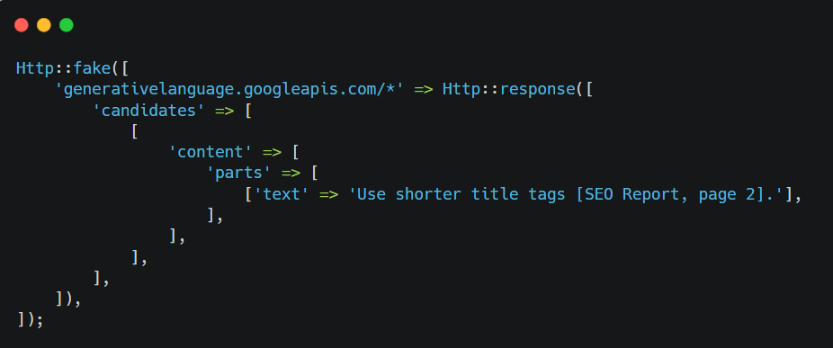
Figure 10: Mocking the language model API response
Test Objectives
- Verify successful API communication.
- Validate prompt construction.
- Confirm response parsing.
- Verify citation preservation.
- Ensure generated responses are returned correctly.
Expected Outcome
The language model returns a valid response based on the supplied document context, and the generated answer is successfully processed by the application.
The automated test also verifies that the generated prompt contains the required contextual information before being transmitted to the external service.
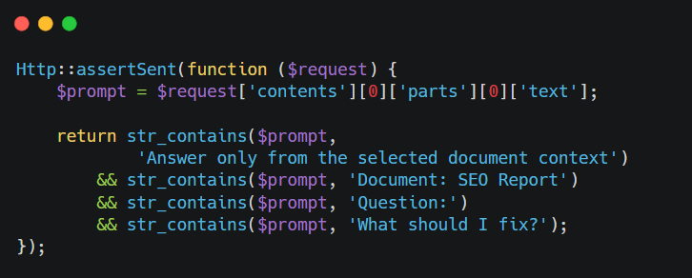
Figure 11: Verifying prompt construction before the language model request

Testing API Failure Scenarios
In addition to successful communication, automated tests verified the application's behaviour when the external services were incorrectly configured or unavailable. Separate test cases confirmed that missing API credentials and unsupported providers resulted in controlled exceptions instead of unexpected application failures.
For example, the embedding service validates that an API key is configured before attempting communication with the external service.
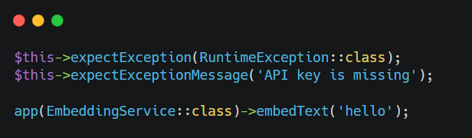
Figure 12: Verifying missing API credentials and unsupported provider configurations
Similar validation tests were implemented for the language model service to verify missing API credentials and unsupported provider configurations.
Test Objectives
- Verify configuration validation.
- Confirm controlled exception handling.
- Prevent unnecessary external requests.
- Ensure predictable application behaviour.
Expected Outcome
Configuration errors are detected immediately, informative exceptions are generated, and the application fails safely without initiating invalid API requests.

Load Testing
Load testing was performed to evaluate the behaviour of the AI-powered document retrieval system under increased workload and concurrent user activities. Unlike unit testing, which verifies the correctness of individual software components, load testing focuses on assessing the application's responsiveness, stability, and resource utilization while processing multiple operations simultaneously.
Since the application performs computationally intensive tasks such as document parsing, text extraction, embedding generation, semantic retrieval, and AI-assisted response generation, it was important to verify that these operations could execute without negatively affecting the responsiveness of the user interface. Particular attention was given to validating the behaviour of the background processing pipeline, database operations, and external AI service integration during periods of increased activity.
The load testing activities concentrated on practical usage scenarios that are representative of how the application is expected to be used in an enterprise environment. These scenarios included uploading multiple documents consecutively, executing several background processing jobs, submitting multiple question-answering requests, and retrieving information from previously processed documents.

Concurrent Document Processing
One of the primary objectives of load testing was to evaluate the document processing pipeline when multiple documents were uploaded within a short period of time. Each uploaded document initiates several computationally intensive operations, including text extraction, document chunking, embedding generation, and database indexing.
To prevent these operations from blocking user interaction, the application executes document processing asynchronously using Laravel's queue system. During testing, multiple documents of different sizes and formats were uploaded consecutively while monitoring queue execution and application responsiveness.
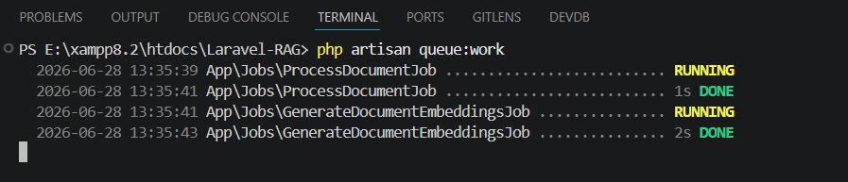
Figure 13: Laravel queue worker processing documents during concurrent uploads
Test Objectives
- Verify successful processing of multiple uploaded documents.
- Confirm correct execution of queued background jobs.
- Validate document status updates throughout processing.
- Ensure that the user interface remains responsive during processing.
- Verify successful completion of document indexing.
Expected Outcome
The application processes multiple uploaded documents sequentially through the queue system while maintaining a responsive user interface. Each document progresses through the expected processing stages until semantic indexing is completed successfully.

Concurrent Question Answering
The conversational interface allows users to submit natural language queries after document processing has been completed. Load testing verified that multiple consecutive question-answering requests could be processed without affecting retrieval quality or application stability.
During testing, multiple queries were submitted against different processed document collections while observing retrieval performance, response generation time, and overall application responsiveness.
The evaluation confirmed that semantic retrieval, prompt generation, and response processing continued to function correctly under repeated user interactions.
Test Objectives
- Verify stable processing of consecutive user queries.
- Confirm successful semantic retrieval for each request.
- Validate generation of context-aware responses.
- Ensure accurate citation generation.
- Maintain consistent application responsiveness.
Expected Outcome
The system successfully retrieves relevant document chunks, generates appropriate responses, and maintains stable performance during repeated conversational interactions.

Database Performance During Retrieval
Semantic document retrieval requires multiple database operations, including similarity search within the vector database and retrieval of associated document metadata. Load testing evaluated whether these operations remained efficient while processing repeated retrieval requests.
The PostgreSQL database together with the pgvector extension was monitored throughout testing to verify that document retrieval remained responsive after indexing larger document collections.
The implemented vector index improved the efficiency of semantic retrieval by enabling similarity searches without scanning every stored document chunk.
Test Objectives
- Verify efficient semantic retrieval.
- Confirm correct vector similarity search.
- Validate retrieval from indexed document collections.
- Ensure stable database performance during repeated searches.
Expected Outcome
Semantic retrieval remains responsive while returning relevant document chunks efficiently, demonstrating that the database structure and vector indexing strategy support practical enterprise workloads.

Overall System Stability
The final stage of load testing evaluated the behaviour of the complete application while multiple software components operated simultaneously. This included document uploads, queue execution, database operations, semantic retrieval, and AI-assisted response generation.
Throughout testing, the application remained operational without unexpected failures or inconsistent processing states. Successfully completed background jobs updated document statuses correctly, retrieval operations returned relevant document content, and generated responses remained consistent throughout repeated execution.
Although the testing was conducted within the development environment rather than a production infrastructure, the observed behaviour demonstrated that the implemented architecture was capable of supporting the expected workload for the current project scope.
Test Objectives
- Verify stable operation under concurrent workloads.
- Confirm successful interaction between software components.
- Validate queue stability.
- Ensure reliable database operations.
- Verify consistent application behaviour throughout testing.
Expected Outcome
The application maintains stable operation while processing multiple concurrent activities, demonstrating that the implemented architecture is suitable for the expected operational workload.

Test Cases
Functional test cases were executed to verify that the implemented features of the AI-powered document retrieval system satisfied the specified functional requirements under realistic operating conditions. Unlike unit testing, which validates individual software components, functional testing evaluates complete application workflows from the user's perspective by verifying interactions between multiple system components.
Each test case was executed after the corresponding feature had been fully implemented and integrated into the application. The testing process covered both normal operating scenarios and exceptional conditions to ensure that document management, background processing, semantic retrieval, and AI-assisted question answering operated reliably under expected usage conditions.
The following test cases summarize the principal functional tests performed during the project.

TC01: Document Upload
Description
This test verifies that an authenticated user can successfully upload a supported document and that the document is accepted by the system for background processing.
Preconditions
- The user must be authenticated.
- The document upload page must be accessible.
- The Laravel queue worker must be running.
- The uploaded document must be one of the supported formats.
Steps
- Open the Documents page.
- Click Upload Document.
- Enter the document title.
- Select a supported document.
- Click Upload.
- Verify that the document appears in the document list.
Test Data
Condition | Expected Outcome
Valid PDF document | Document uploaded successfully
Valid DOCX document | Document uploaded successfully
Valid XLSX document | Document uploaded successfully
Unsupported file format | Validation error displayed
Missing document title | Validation error displayed
Table 1: TC01 – Document Upload Test Data
Expected Results
- The document is uploaded successfully.
- A new document record is created.
- The document enters the background processing queue.
- The processing status is displayed to the user.
Actual Results
- The document was uploaded successfully.
- The document record was created correctly.
- Background processing started automatically.
- The document status changed to Queued.
Postconditions
- The uploaded document is available for background processing.
- The document appears in the user's document repository.
Status: Passed
TC02: Document Processing Pipeline
Description
This test verifies that uploaded documents progress successfully through the complete document processing pipeline, including text extraction, document chunking, embedding generation, and semantic indexing.
Preconditions
- A supported document has been uploaded.
- The queue worker is running.
- External AI services are properly configured.
Steps
- Upload a supported document.
- Monitor the document processing status.
- Wait for processing to complete.
- Verify that the document status changes to Completed.
Test Data
Condition | Expected Outcome
PDF document | Processing completed successfully
Word document | Processing completed successfully
Excel document | Processing completed successfully
Missing AI configuration | Processing fails with appropriate error
Table 2: TC02 – Document Processing Pipeline Test Data
Expected Results
- Text extraction completes successfully.
- Document chunks are generated.
- Embeddings are generated.
- Semantic indexing completes successfully.
- The document status changes to Completed.
Actual Results
- All processing stages completed successfully.
- The document became available for semantic retrieval.
- Processing status was updated correctly throughout the workflow.
Postconditions
- The processed document is available for question answering.
Status: Passed

TC03: AI-Assisted Question Answering
Description
This test verifies that the system retrieves relevant document information and generates context-aware responses for user questions.
Preconditions
- At least one processed document exists.
- A conversation has been created.
- External AI services are available.
Steps
- Create a new conversation.
- Select one or more processed documents.
- Enter a question.
- Submit the question.
- Review the generated response.
Test Data
Condition | Expected Outcome
Question related to uploaded document | Relevant response generated
Question outside document scope | Appropriate response generated based on the context
Follow-up question | Conversation context preserved
Table 3: TC03 – AI-Assisted Question Answering Test Data
Expected Results
- Relevant document chunks are retrieved.
- A context-aware response is generated.
- Supporting document references are included.
- The response is stored in the conversation history.
Actual Results
- Relevant information was successfully retrieved.
- The generated response reflected the uploaded document content.
- Document references were displayed correctly.
- The conversation history was updated successfully.
Postconditions
- The conversation contains both the user question and the generated response.
Status: Passed
TC04: Multi-Document Retrieval
Description
This test verifies that the system can retrieve relevant information from multiple selected documents and generate a unified response.
Preconditions
- Multiple processed documents exist.
- The selected documents contain related information.
Steps
- Create a new conversation.
- Select multiple processed documents.
- Submit a question requiring information from several documents.
- Review the generated response.
Test Data
Condition | Expected Outcome
Two related documents selected | Combined response generated
Three or more documents selected | Relevant information retrieved from multiple sources
Single document selected | Response generated using only the selected document
Table 4: TC04 – Multi-Document Retrieval Test Data
Expected Results
- Relevant information is retrieved from the selected documents.
- A consolidated response is generated.
- Appropriate document references are displayed.
Actual Results
- Information was successfully retrieved from multiple documents.
- The generated response accurately combined relevant document content.
- Supporting references were presented correctly.
Postconditions
- Conversation history contains the generated response.
Status: Passed
TC05: Conversation History
Description
This test verifies that previous conversations remain available and that follow-up questions continue within the same conversation context.
Preconditions
- An existing conversation containing previous messages is available.
Steps
- Open an existing conversation.
- Review previous questions and responses.
- Submit a follow-up question.
- Verify that the conversation is updated.

Test Data
Condition | Expected Outcome
Existing conversation | Previous messages displayed
Follow-up question | Conversation updated correctly
Table 5: TC05 – Conversation History Test Data
Expected Results
- Previous conversation history is displayed.
- Follow-up questions are stored correctly.
- New responses are added to the existing conversation.
Actual Results
- Conversation history was displayed successfully.
- Follow-up interaction remained within the same conversation.
- The new response was stored correctly.
Postconditions
- The conversation contains the complete interaction history.
Status: Passed
TC06: Document Deletion
Description
This test verifies that users can successfully remove uploaded documents and that the deleted documents are no longer available within the system.
Preconditions
- A document exists in the user's repository.
- The user is authenticated.
Steps
- Open the Documents page.
- Select an existing document.
- Click Delete.
- Confirm the deletion.
- Verify that the document is removed.
Test Data
Condition | Expected Outcome
Existing document | Document deleted successfully
Previously deleted document | Appropriate error or unavailable record
Table 6: TC06 – Document Deletion Test Data
Expected Results
- The selected document is deleted successfully.
- The document no longer appears in the document list.
- Associated processed information is removed from the system.
Actual Results
- The document was deleted successfully.
- The document was removed from the repository.
- Associated records were removed correctly.
Postconditions
- The deleted document is no longer accessible.
Status: Passed

